

**FPT ACADEMY INTERNATIONAL**

**FPT – APTECH COMPUTER EDUCATION**

**WILSON_SPORTING_GOODS**

|  |  |  |  |
| --- | --- | --- | --- |
| **Center Name** | | ACE-HCMC-2-FPT  Address: 590 Cach Mang Thang Tam, District 3, Ho Chi Minh City | |
| **Instructor** | | Mr. Ngo Phuoc Nguyen | |
| **Class** | | T1.2005.E3 | |
| **Group** | | 4 | |
| **Group members** | | **Name** | **Student ID** |
| Nguyen Huu Thang | Student1267393 |
| Ngo Hong Phuc | Student1266805 |
| Do Quang Thanh | Student1268343 |
| **Duration** | **Start date** | 1st August 2020 | |
| **End date** | 1st September 2020 | |
|  |  |  | |

**This is to certify that**

**Mr./Ms.:**

NGUYEN HUU THANG

NGO HONG PHUC

DO QUANG THANH

**has successfully designed & developed**

eProject: Wilson_Sporting_Goods

**Submitted by:**

Nguyen Huu Thang­­­

**Date of issue:**

August 8th 2020

**Authorized Signature:**

**TABLE OF CONTENTS**

ACKNOWLEDGEMENT 4

SYNOPSIS 4

PROBLEM STATEMENT 5

CUSTOMER'S REQUIREMENTS SPECIFICATIONS 6

SCOPE OF THE WORK (IN BRIEF) 7

ARCHITECTURE AND DESIGN OF THE SYSTEM 7

DIAGRAM OF THE WEBSITE 8

SITE MAP 10

MOCK OF THE WEBSITE 11

1. Home page Layout Plan 11

2. Main Layout Plan 12

3. Product Layout Plan 13

4. Product Detail Layout Plan 14

5. Product Comparison Layout Plan 14

6. Contact Layout Plan 15

7. About Us Layout Plan 15

8. Sign In Layout Plan 16

WEBSITE DESCRIPTION 18

1. Home Page 18

2. Product Page 20

3. Contact Us 24

4. About Us 27

5. Sign In 28

# 

# ACKNOWLEDGEMENT

It is often said that “Gratitude is the sign of noble souls”. That’s why we devote this chapter to express our deep gratitude towards those who have supported and guided us to accomplish this e-Project successfully.

First and foremost, we strongly appreciate the invaluable assistance that our beloved instructor – Mr. Ngo Phuoc Nguyen, has offered us. Whenever problems come up, he’ll always the one that we can count on for solutions. Anytime when our team chose a wrong way, Mr. Nguyen gave us a pep talk to keep us back on the track. Therefore, once again, we truly value your dedication and guidance, Mr. Ngo Phuoc Nguyen.

Next, it would have been impossible to carry out and complete this project without the collaboration among our team members. Although we have gone through many obstacles during the project implementation, eventually we gained what we aimed at by our hard work, our strong commitment and of course, our friendship.

Finally, thanks to this e-Project assignment, we had a golden opportunity to apply what we have learnt into reality and gain hands-on experience which is essential for our future career.

# SYNOPSIS

The Wilson Sporting Goods Company is an [American](https://en.wikipedia.org/wiki/United_States" \o "United States) [sports equipment](https://en.wikipedia.org/wiki/Sports_equipment) manufacturer based in [Chicago](https://en.wikipedia.org/wiki/Chicago" \o "Chicago), [Illinois](https://en.wikipedia.org/wiki/Illinois). From 1989 till 2019 , it has been a [subsidiary](https://en.wikipedia.org/wiki/Subsidiary" \o "Subsidiary) of the [Finnish](https://en.wikipedia.org/wiki/Finland" \o "Finland) group [Amer Sports](https://en.wikipedia.org/wiki/Amer_Sports).[[3]](https://en.wikipedia.org/wiki/Wilson_Sporting_Goods#cite_note-3) Wilson makes equipment for many sports, among them [baseball](https://en.wikipedia.org/wiki/Baseball" \o "Baseball), [badminton](https://en.wikipedia.org/wiki/Badminton), [American football](https://en.wikipedia.org/wiki/American_football), [basketball](https://en.wikipedia.org/wiki/Basketball), [fastpitch softball](https://en.wikipedia.org/wiki/Fastpitch_softball), [golf](https://en.wikipedia.org/wiki/Golf), [racquetball](https://en.wikipedia.org/wiki/Racquetball), [soccer](https://en.wikipedia.org/wiki/Association_football), [squash](https://en.wikipedia.org/wiki/Squash_(sport)), [tennis](https://en.wikipedia.org/wiki/Tennis), [pickleball](https://en.wikipedia.org/wiki/Pickleball) and [volleyball](https://en.wikipedia.org/wiki/Volleyball).

The company owns the brands Atec, [DeMarini](https://en.wikipedia.org/wiki/DeMarini" \o "DeMarini), [EvoShield](https://en.wikipedia.org/wiki/EvoShield), [Louisville Slugger](https://en.wikipedia.org/wiki/Hillerich_%26_Bradsby), and Luxilon to provide sports equipment and protective gear for baseball, lacrosse, softball, and tennis. It has announced a partnership with the NBA for the 2021-22 season.

# PROBLEM STATEMENT

After reading the requirements from Wilson, our group has discussed about what should to be done to fulfill them properly. We came to conclusion that in order to achieve the best result, we should deal with following queries:

1. How many tabs should be displayed?
2. How is each web page designed to offer users the enjoyable experience?
3. How is GeoLocation API function programmed?
4. How do web users interact with the website?
5. Will the web run successfully on web browsers?

Additionally, the website will be built to run efficiently only on Windows platform. However, it still can be compatible on all leading web browsers such as Chrome, IE and Firefox. We make use of HTML5, Bootstrap, Jquery and AngularJs to create a website that both runs smoothly and has a friendly UI.

# 

# CUSTOMER'S REQUIREMENTS SPECIFICATIONS

1. **Client: *Wilson Sporting Goods*** website
2. **Business/Project Objective:**

WILSON SPORTING GOODS is selling various types of Sports Goods. The company advertises by distributing the pamphlets, advertising on television and so on. Due to rapid development in internet field, the company decides to launch a website where people will get all the information about the various products available with them easily.

1. **Input to the system:**

* **From webmaster:**
* Information about sporting products.
* Contact details for users to keep in touch with Wilson.com.
* Location of the shop
* **From web users:**
* User traverse products of brands.
* Downloaded or viewed detailed Features of products.
* Requesting information to Wilson Shop by contact email.
* **Output from the system:**
* Displaying the attraction information that the user would like to know, including images and description.
* Locating Wilson shop and users location.

1. **Hardware/ Software Requirements**

* **For webmaster**

**Hardware**

* Intel Pentium 4 processor or higher
* 1 Gigabytes of RAM or higher

**Software**

* Windows 7 OS or higher
* Visual Studio Code and Webstorm
* HTML5 and Javascript supporting web browsers such as IE, Chrome or Firefox
* **For web users**

**Hardware**

* Intel Pentium 4 processor or higher
* 512 Megabytes of RAM or higher

**Software**

* Windows XP OS or higher
* HTML5 and Javascript supporting web browsers such as IE, Chrome or Firefox

# SCOPE OF THE WORK (IN BRIEF)

A long and detailed discussion, our group has decided to create a website contain the following webpages after:

1. ***Homepage***: display a menu which will contain the options for brief introduction about the various sporting goods available, location of the shop, any other information if required and contain details of Sports Goods with suitable images.
2. ***Basketball***: Display a product catalogue belong to several brands. User can use filter function by brands
3. ***Football***: Display a product catalogue belong to several brands. User can use filter function by brands
4. ***Badminton***: Display a product catalogue belong to several brands. User can use filter function by brands
5. ***Comparison***: The user also be able to compare the various products of different as well as similar brands.
6. ***Contact Us***: Displayed using GeoLocation API (eg. GoogleMaps) and the email address
7. ***About Us:*** Introduce the team member

# ARCHITECTURE AND DESIGN OF THE SYSTEM

Webpage request

**WEB BROWSER**

**WEB SERVER**

Requested Page

**RENDERING ENGINE**

INTERPRETATION

INTERPRETATION

# DIAGRAM OF THE WEBSITE

**HOME (index.html)**

**BASKETBALL (product.html)**

**FOOTBALL (product.html)**

**BADMINTON (product.html)**

**SIGN IN (signin.html)**

**CONTACT US (contact.html)**

**ABOUT US (aboutus.html)**

**TASK SHEET REVIEW 1**

|  |  |  |  |  |  |  |  |
| --- | --- | --- | --- | --- | --- | --- | --- |
| **Project Ref. No.:**  **eP/Advertisement** **Portal Management** **System/01** | | **Project Title:** | **Activity Plan** **Prepared** **By:** | **Date of Preparation of Activity Plan:** | | | |
| **Sr.No.** | **Task** | **Actual Start** **Date** | **Actual** **Days** | **Team** **Mate** **Names** | **Status** |
| 1 | Problem Statement | Wilson Sporting goods | All members | 1st Aug | 1 | All | Completed |
| 2 | Analysis of Wilson requirements about the website | 1st Aug | 1 | All | Completed |
| 3 | The scope of the work (in brief) | 1st Aug | 1 | All | Completed |
| 4 | Architecture and design of the system | 2nd Aug | 1 | All | Completed |
| 5 | Diagram of the website | 2nd Aug | 1 | All | Completed |
| 6 | Task Sheet | 2nd Aug | 1 | All | Completed |

|  |  |
| --- | --- |
| Date: | |
| Signature of Instructor  **Mr. Ngo Phuoc Nguyen** | Signature of Team Leader  **NGUYEN HUU THANG** |

# SITE MAP

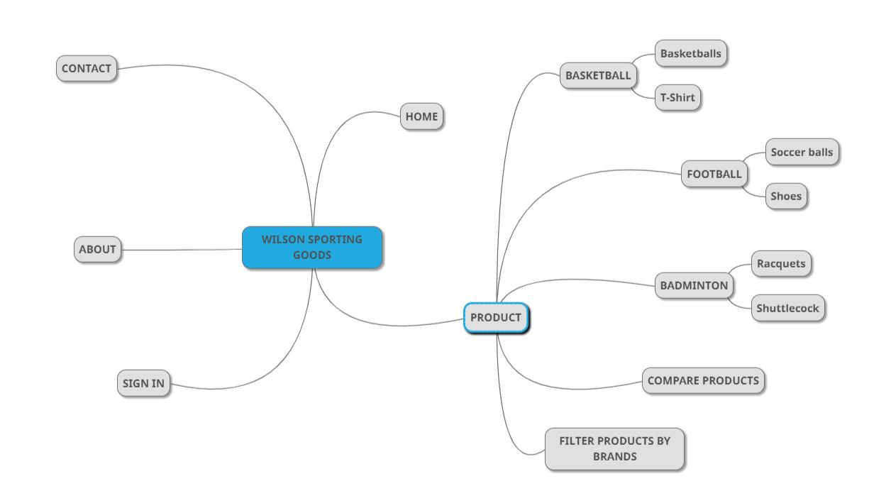

**MOCK OF THE WEBSITE**

We divide the website structure into layouts which will be displayed below.

**1.HOME PAGE (index.html):**

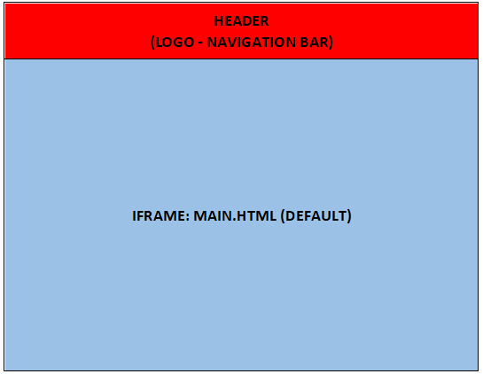

**2.MAIN (main.html):**

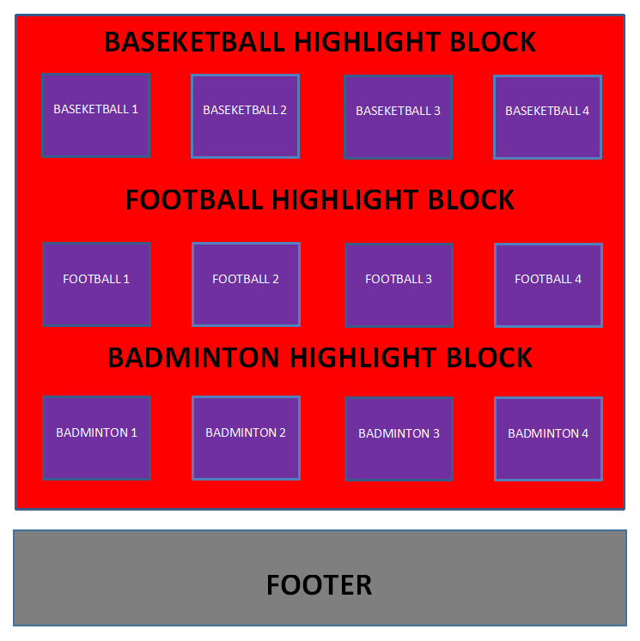

**3.PRODUCT (product.html):**

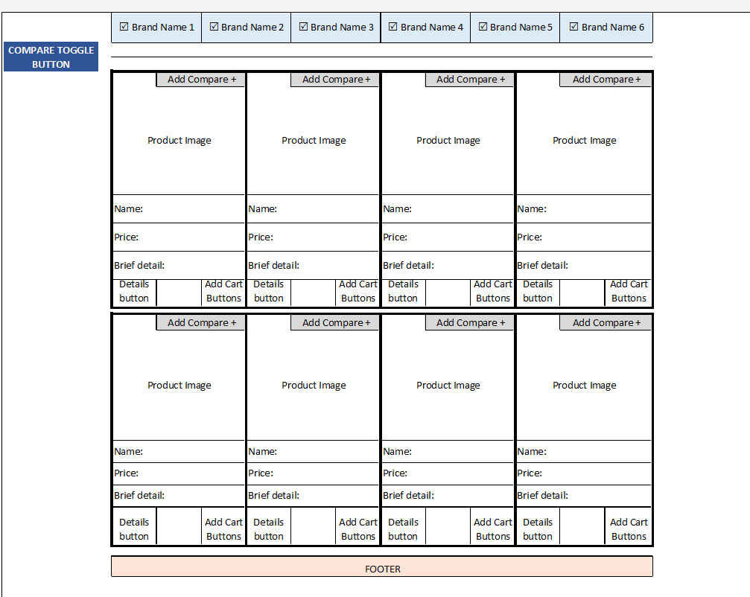

**3.1 PRODUCT DETAILS (detail button click):**

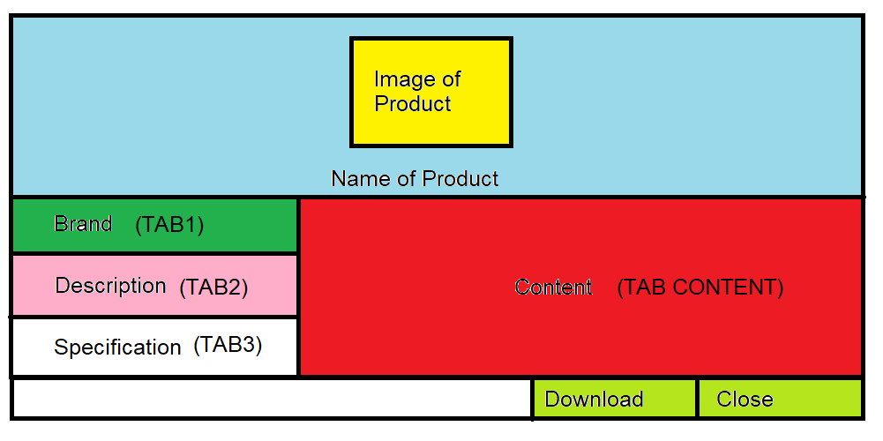

**3.2 PRODUCT COMPARISON (compare button click):**

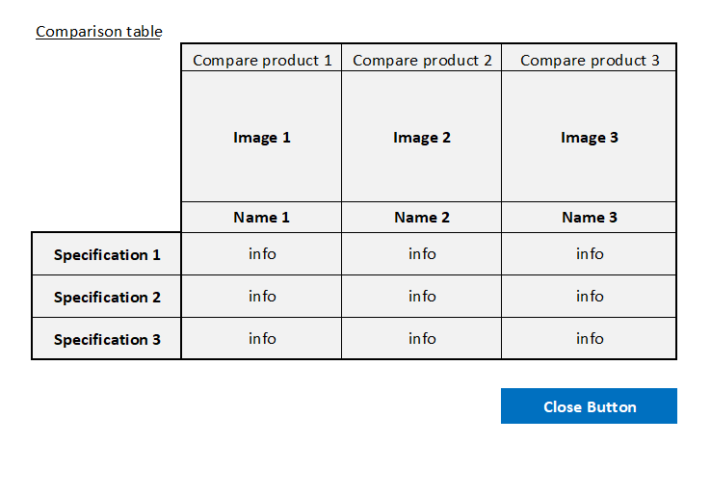

**4.CONTACT (contact.html):**

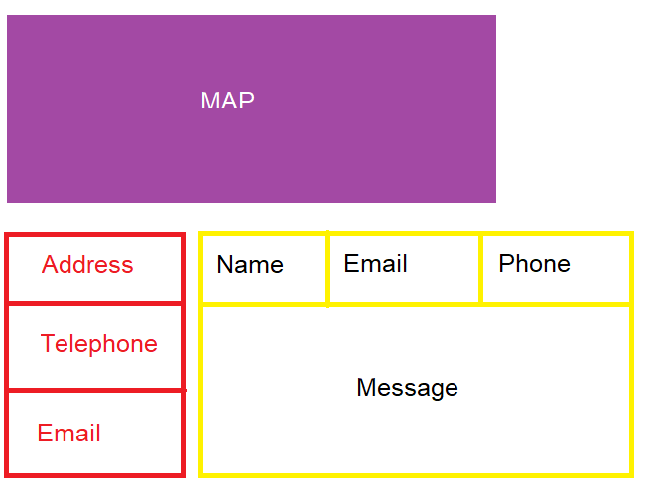

**5.ABOUT US:**

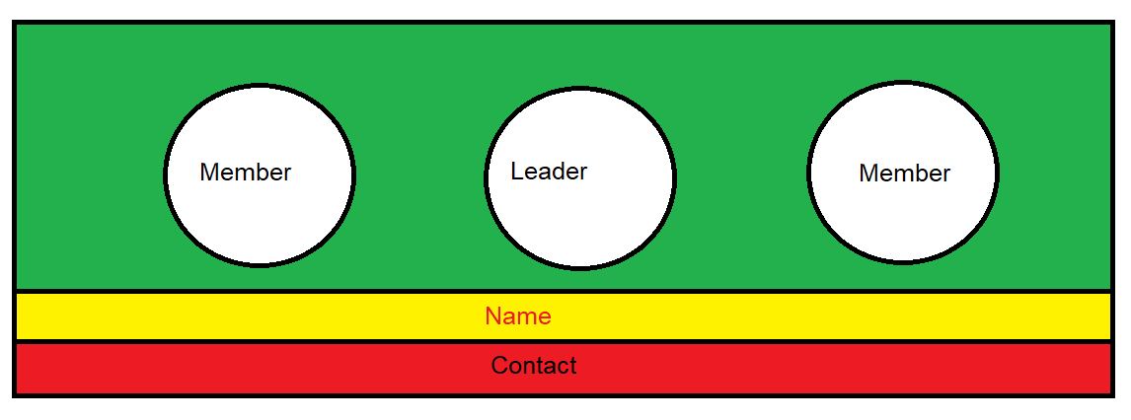

**6.SIGN IN (signin.html):**

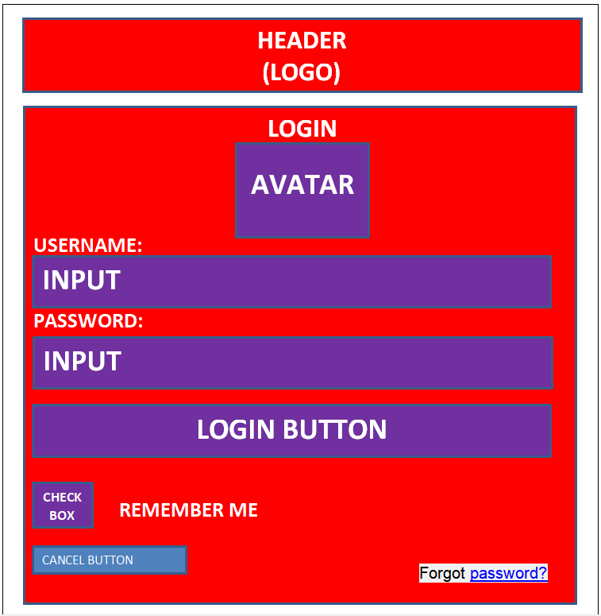

**TASK SHEET REVIEW 2**

|  |  |  |  |  |  |  |  |
| --- | --- | --- | --- | --- | --- | --- | --- |
| **Project Ref. No.:**  **eP/Advertisement** **Portal Management** **System/01** | | **Project Title:** | **Activity Plan** **Prepared** **By:** | **Date of Preparation of Activity Plan:** | | | |
| **Sr.No.** | **Task** | **Actual Start** **Date** | **Actual** **Days** | **Team** **Mate** **Names** | **Status** |
| 1 | Site map | Wilson sporting goods | All members | 17th Aug | 5 | THANH | Completed |
| 2 | Mock of the website | 17th Aug | 5 | ALL | Completed |
| 3 | Home Page Layout Plan | 17th Aug | 5 | PHUC | Completed |
| 4 | Main Layout Plan |  |  | 17th Aug | 5 | PHUC | Completed |
| 5 | Product Layout Plan |  |  | 17th Aug | 5 | THANH | Completed |
| 6 | Product Detail Layout Plan |  |  | 17th Aug | 5 | THANG | Completed |
| 7 | Product Comparison Layout Plan |  |  | 17th Aug | 5 | THANH | Completed |
| 8 | Contact Us Layout Plan |  |  | 17th Aug | 5 | THANG | Completed |
| 9 | About Us Layout Plan |  |  | 17th Aug | 5 | THANG | Completed |
| 10 | Sign In Layout Plan |  |  | 17th Aug | 5 | PHUC | Completed |
| 11 | Take Sheet |  |  | 22nd Aug | 1 | THANG | Completed |

|  |  |
| --- | --- |
| **Date:** | |
| Signature of Instructor:  **Mr. Ngo Phuoc Nguyen** | Signature of Team Leader:  **Nguyen Huu Thang** |

# WEBSITE DESCRIPTION

At this time, our group has just completed some main parts of Wilson such as homepage, products and contacts. The content and design of the website currently are not the final official version, so they may not have the most beautiful appearance.

1. **Home Page:**

There elements will always be on top of all pages of the website; from here users can easily jump into any categories at any time or return to the homepage by clicking on the name of the elements in the menu which they are interested in



After that, we show brief advertising of product such as: advertising carousel which can auto changes slides and advertising banner.

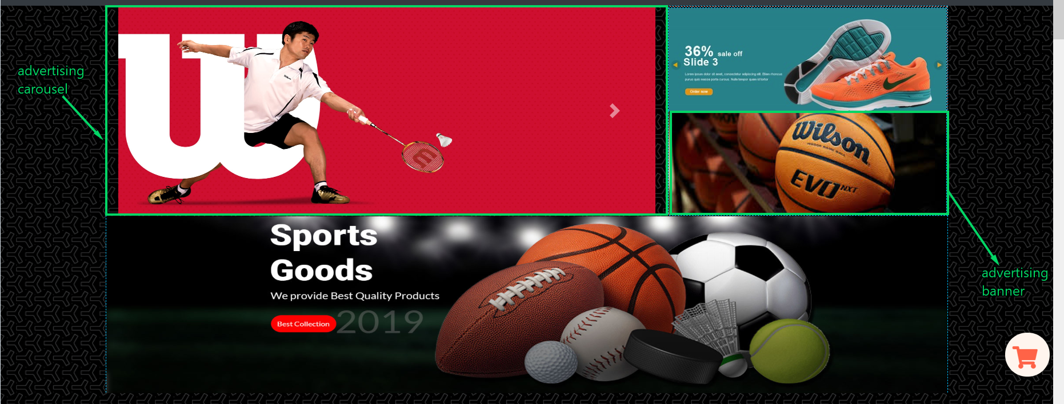

Main of Homepage: we show a table of our highlight products:

+ Basketball products

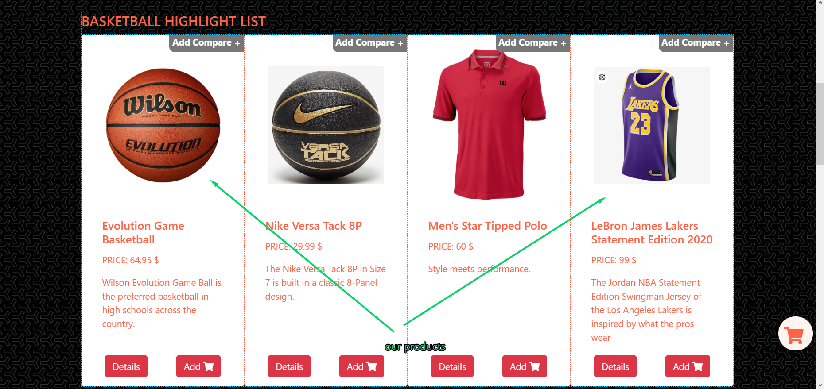

+ Football products

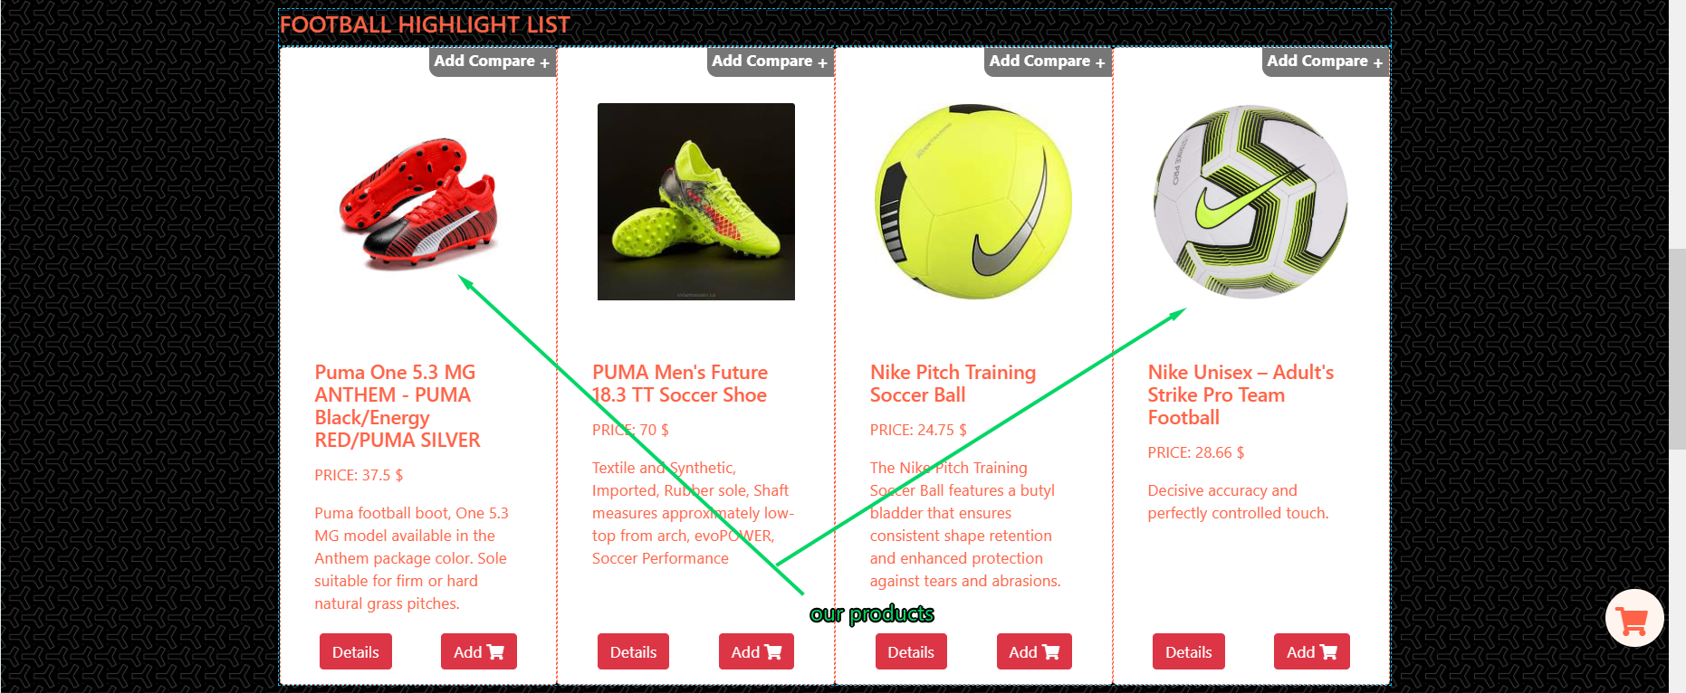

+Badminton products

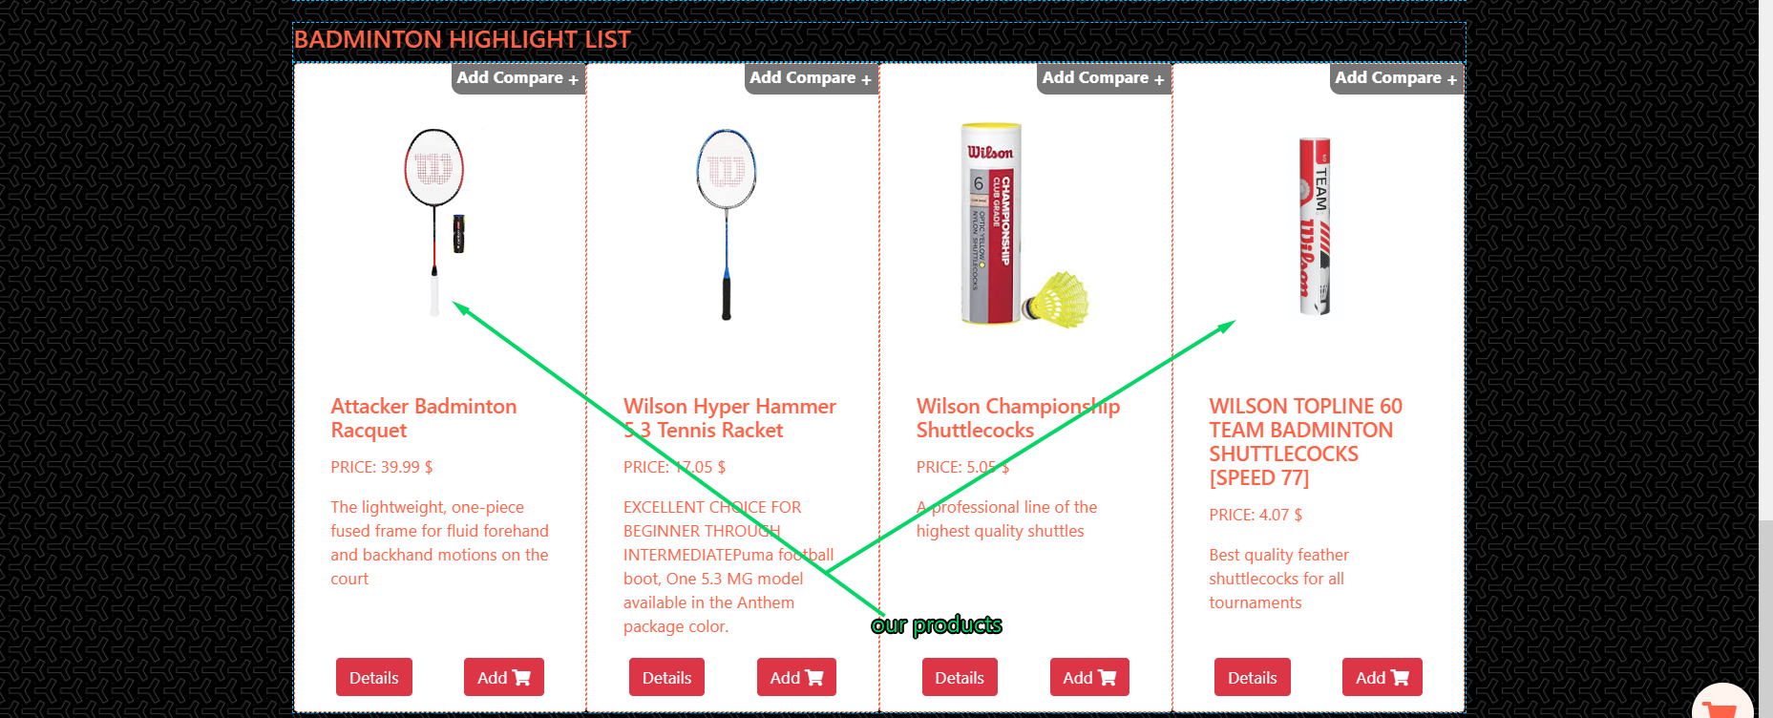

Final the footer which have stander of Wilson Sporting Goods include in: phone, email, time and exact location.

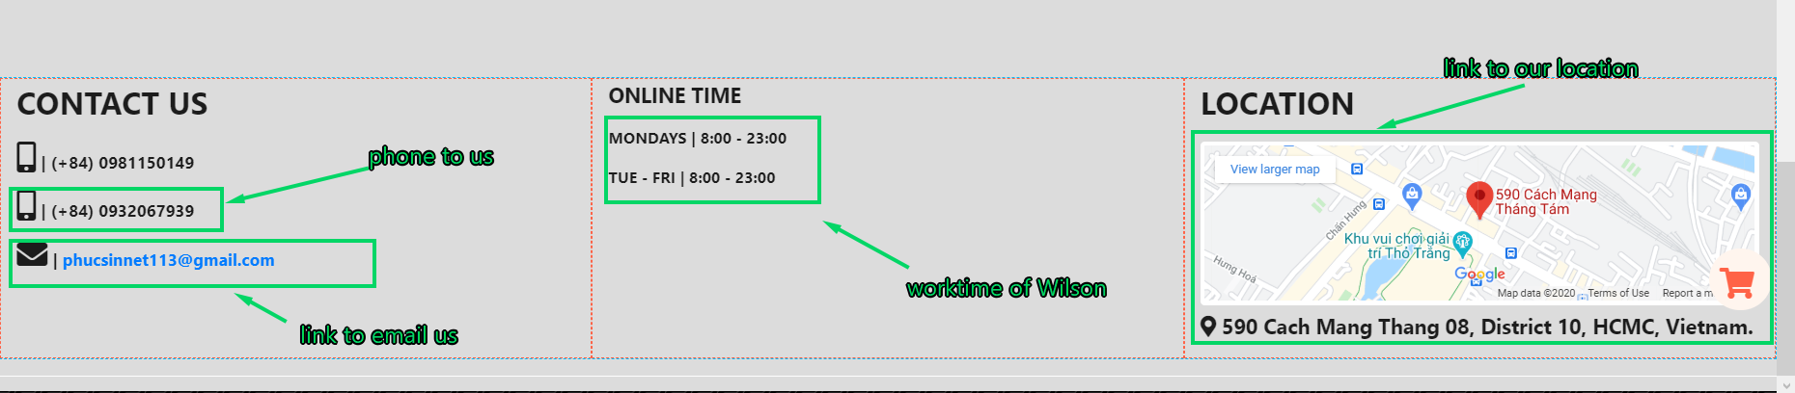

1. **Product Page:**

After navigate to the specific product type, this page shows relevant brand name and their products along with brief information as layout below:

Default display shows all product of the type of all relevant brand name.

This page contains 04 main functions:

1- Show list of brand names and products with brief information via cards

2- Show details information each product by clicking on “Details button” in the card.

3- Filter products by brand name

4- Compare products of the same type of different brand name as well as same brand name.

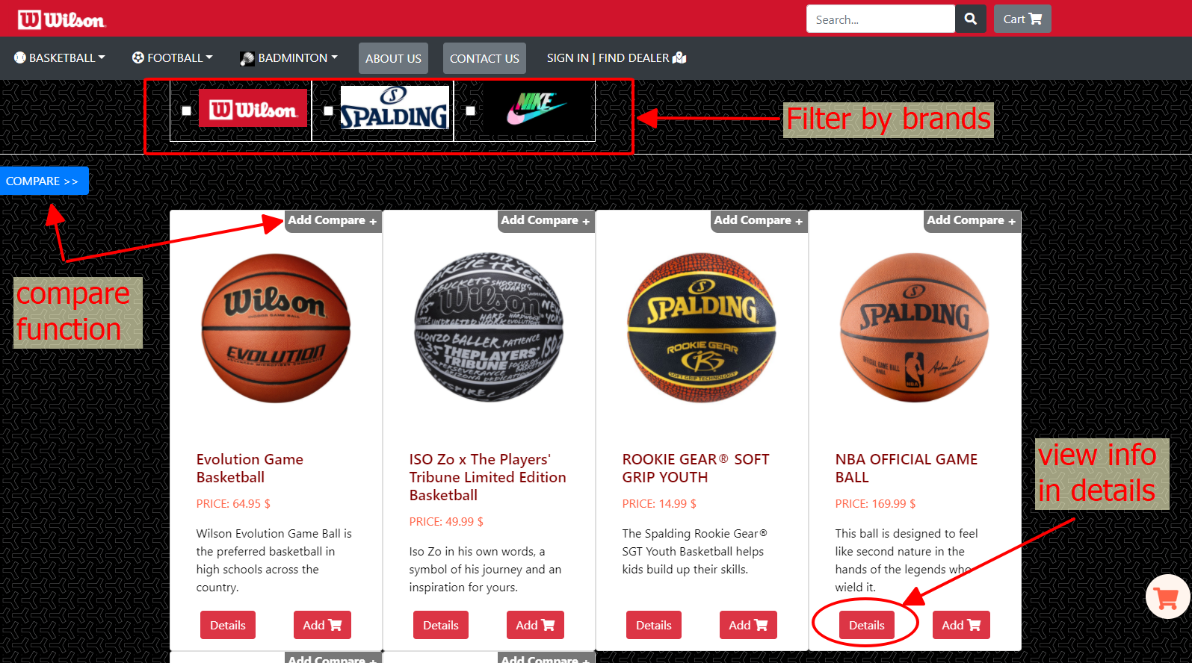

***1- Show list of brand names and products with brief information via cards***

* The relevant brand name is a list of check box created via JS code by select from JSON data with condition is product type.

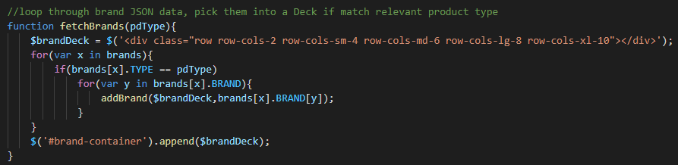

* The relevant products are a list of cards created via JS code by select from JSON data with conditions are product type, brands, …

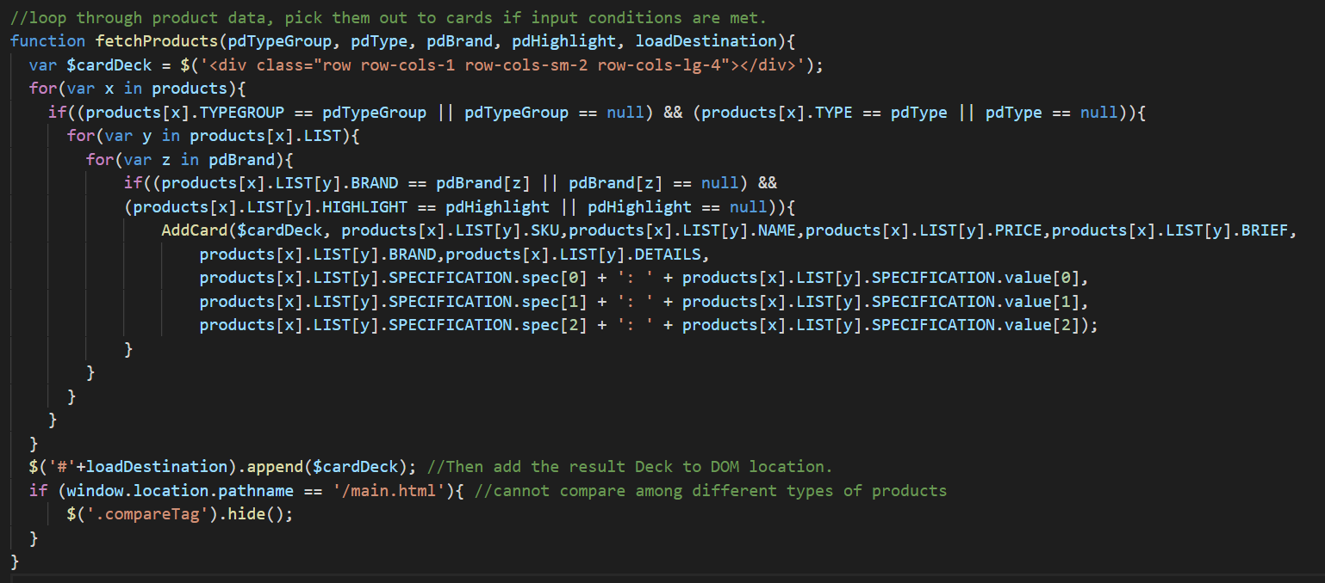

***2- Show details information each product by clicking on “Details button” in the card.***

Details of product can be shown by click on the Details button of each card.

The JS script listen click event on the button and retrieve information in the card and load on to the overlay which cover full viewport. A nav pill tabbed navigate details to aside tab view.

An overlay will appear. As below photo: 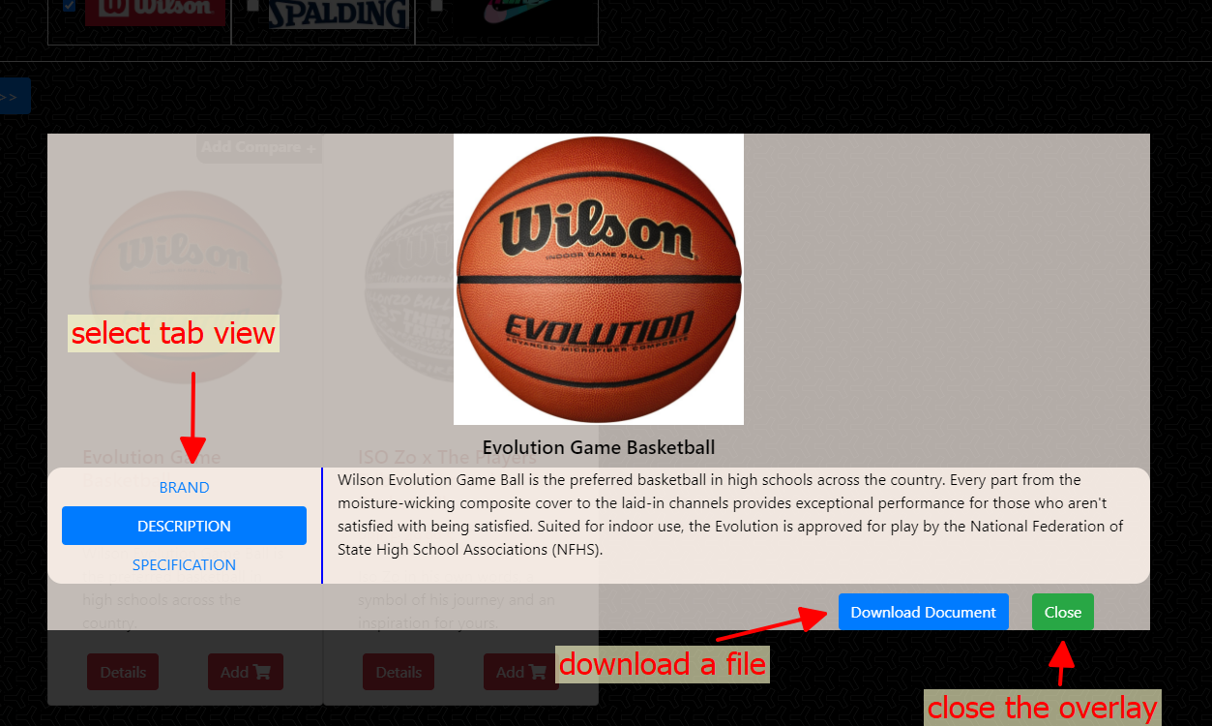

***3- Filter products by brand name***

Then user can filter products by brand name here by choosing the brand name check boxes.

Each product card is marked by its own brand in class attribute, a JS script listen click event on check boxes, all checked brand will call their marked cards show respectively while the unchecked ones hide their cards.

User guild as photo below:

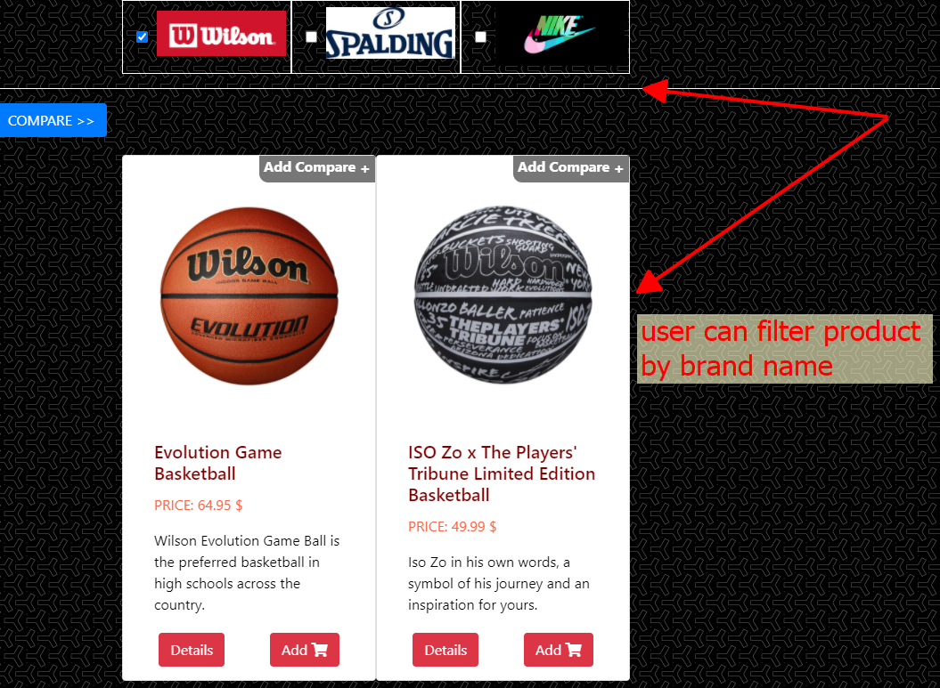

***4- Compare products of the same type of different brand name as well as same brand name.***

While browsing goods, user can pick them in comparison to have an overview of their different specifications.

By clicking on “Add Compare” tag on the right-top corner of the card, the item will be toggle into compare list.

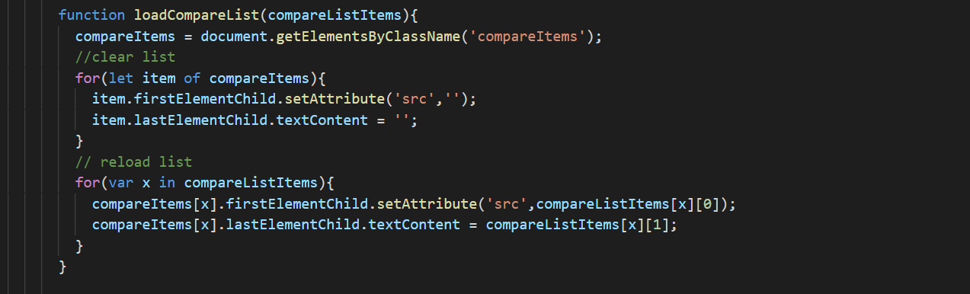

Then a panel slide from the left contain compared items. When user chose at least 02 items, “Compare Now” button will be ready to take an action.

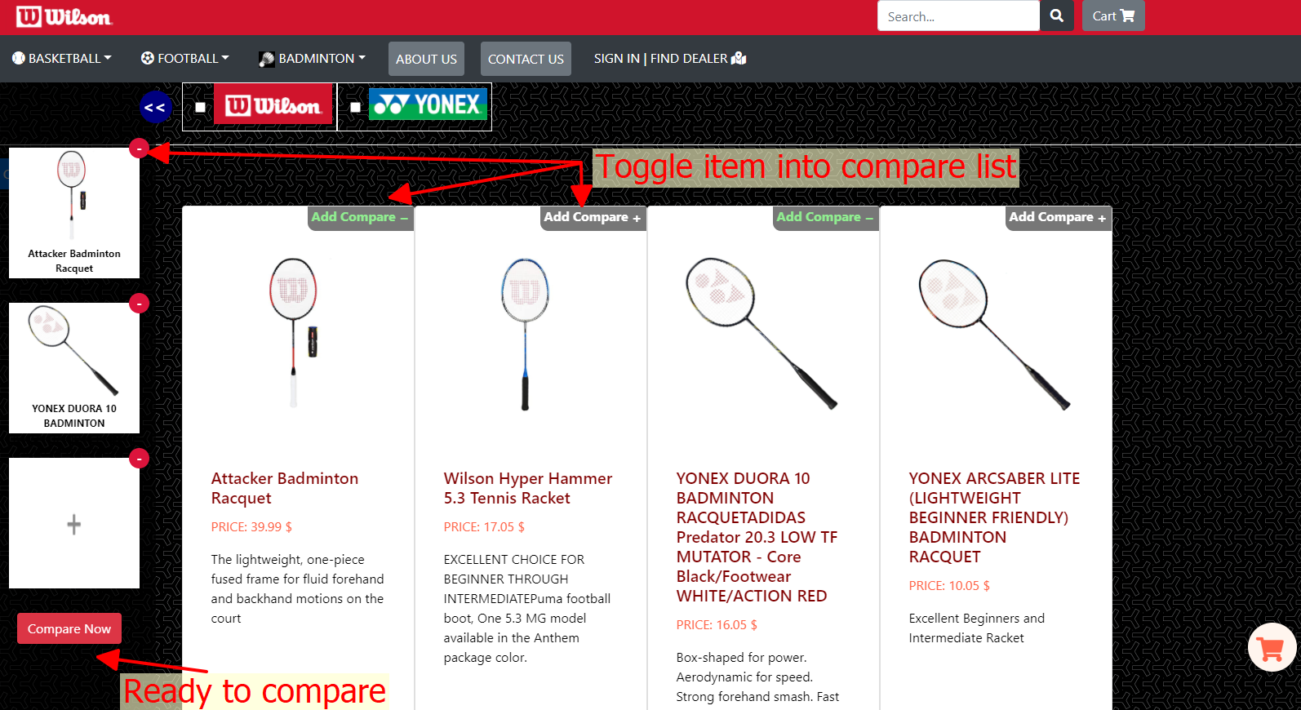

When user take comparison an overlay will display a table in which show comparison information to user.

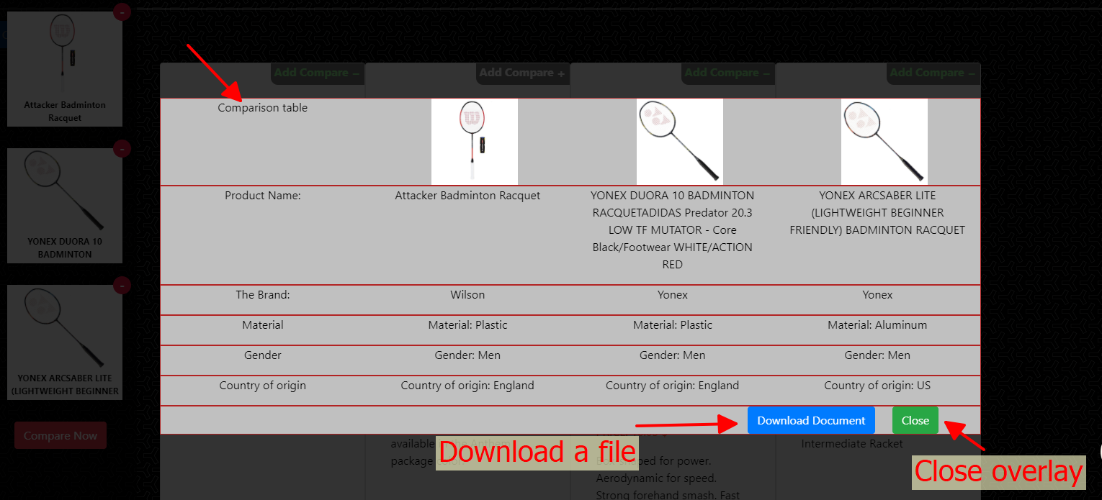

1. **Contact Us:**

There should be a “Contact Us” page that includes the Address of the Wilson store. Company addresses must be displayed using the GeoLocation API (eg GoogleMaps).

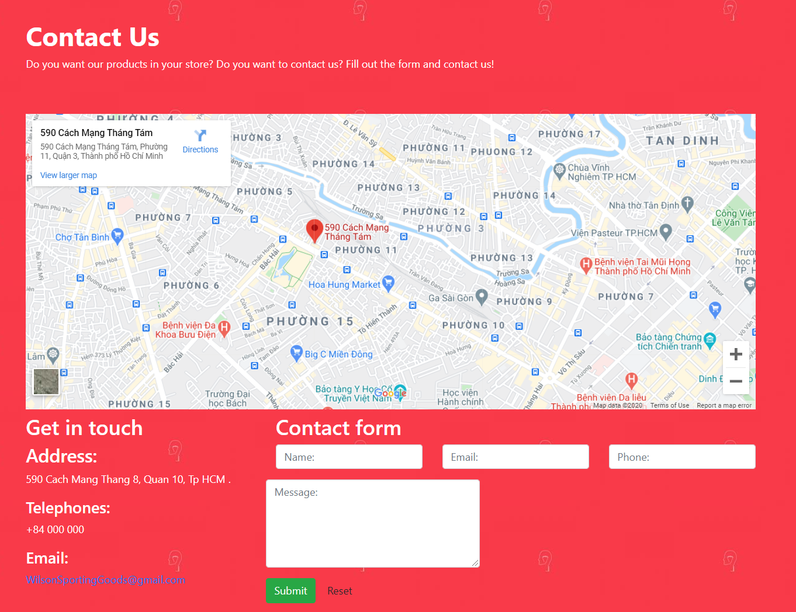

The page information includes the get in touch and contact form:

* Get in touch: The address of the Wilson store.
* Contact form: Section for customers to fill in personal information if you want to ask questions.

Note:

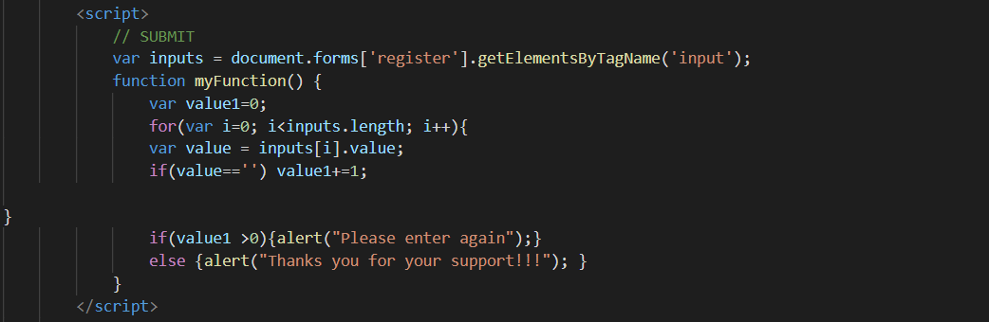

* If the customer entered is not valid, the page will be displayed:

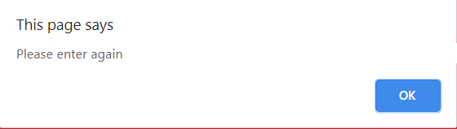

* If successfully entered, the page will be displayed:

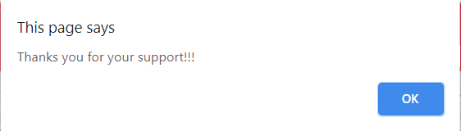

In addition, there is also a reset button when you want to delete all information you have entered.

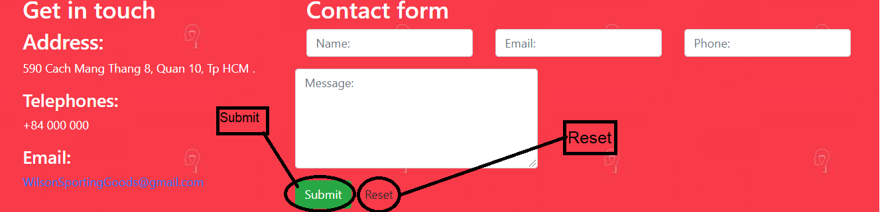

When clicking Email, the page will be displayed as follows:

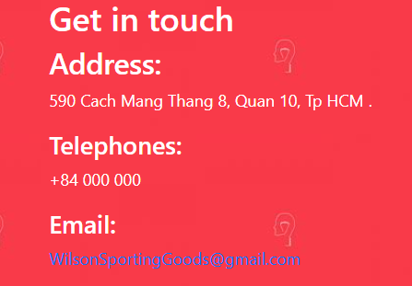

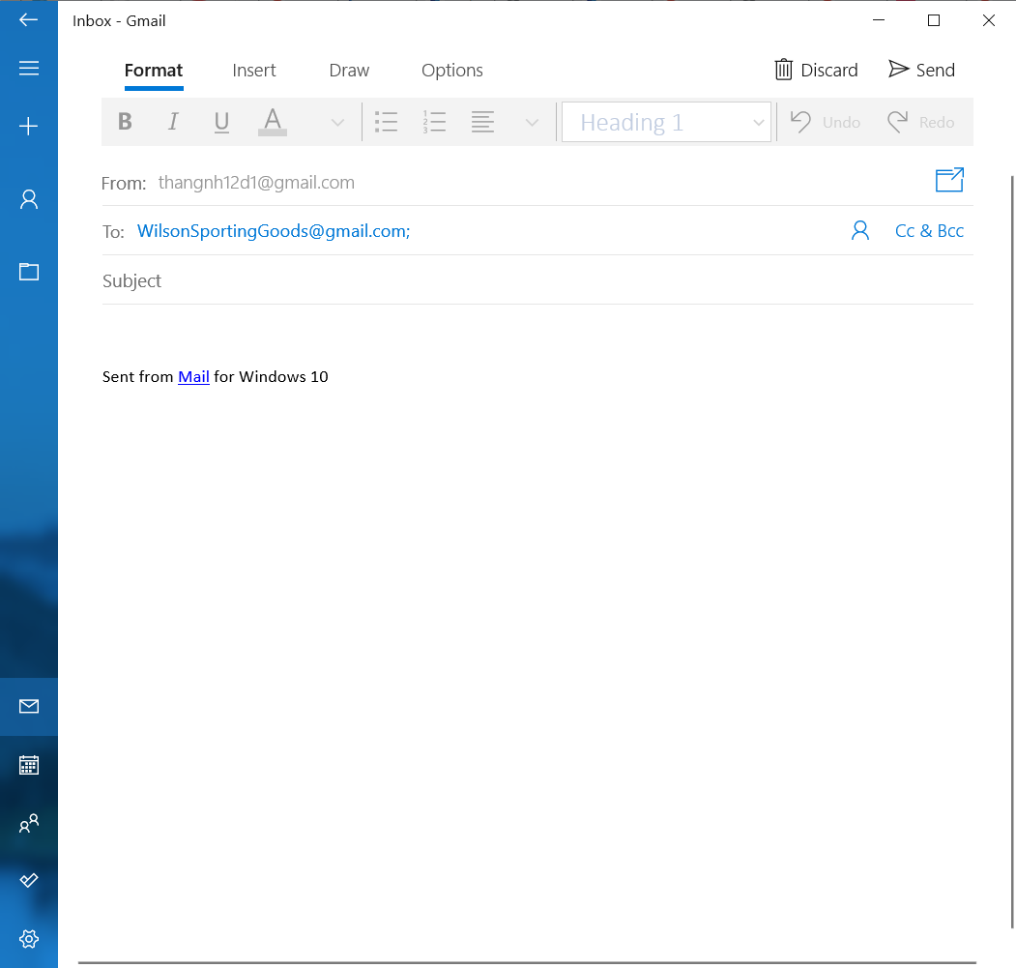

1. **About Us:**

This page will contain information of team members including Team leader and Member dev (contacts include Facebook, Gmail, phone number).

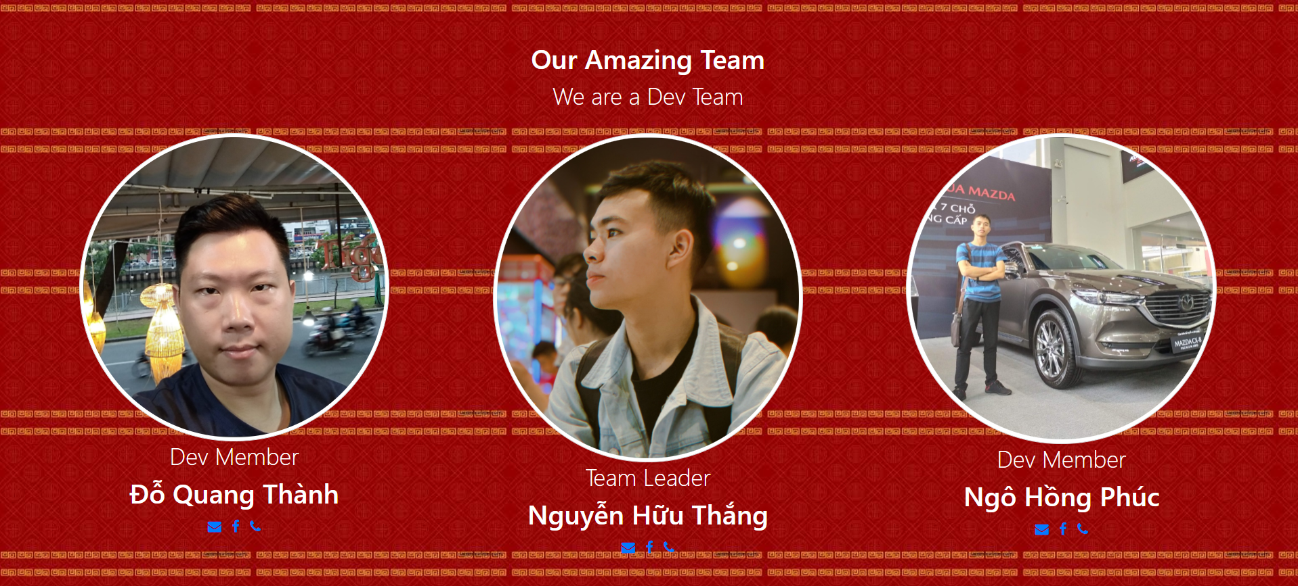

1. **Sign In:**

In the top we ha the logo of Wilson Sporting Goods. Then the Login Form which get user information with elements below the picture:

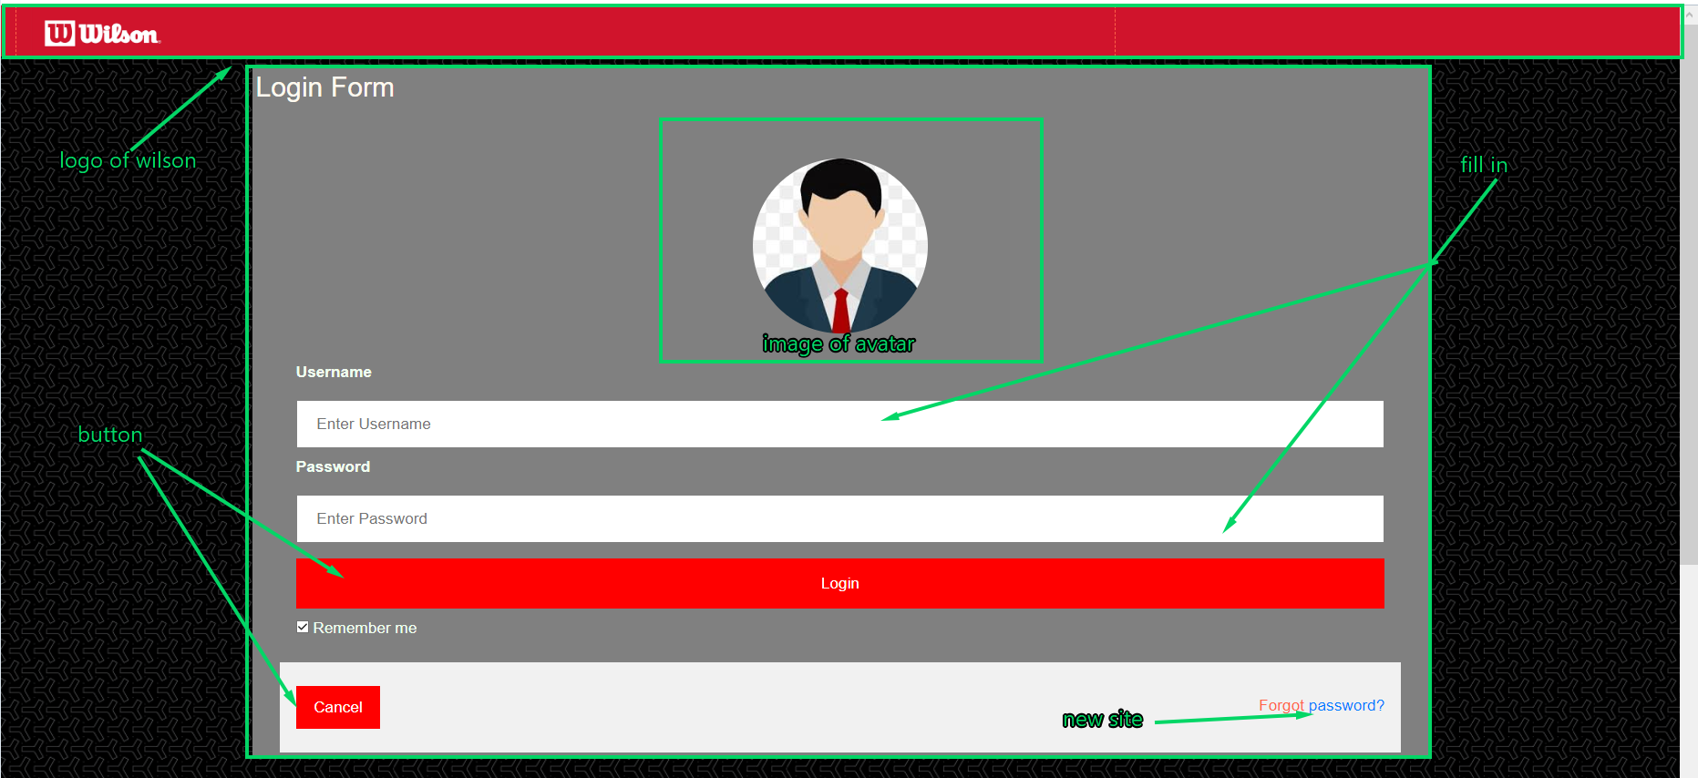

The footer which have stander of Wilson Sporting Goods include in: phone, email, time and exact location.

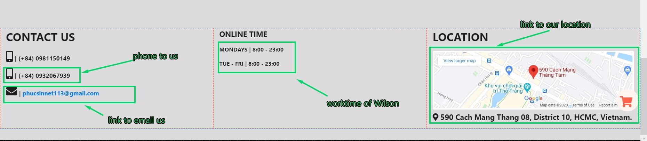

**TASK SHEET REVIEW 3**

|  |  |  |  |  |  |  |  |
| --- | --- | --- | --- | --- | --- | --- | --- |
| **Project Ref. No.:**  **eP/Advertisement** **Portal Management** **System/01** | | **Project Title:** | **Activity Plan** **Prepared** **By:** | **Date of Preparation of Activity Plan:** | | | |
| **Sr.No.** | **Task** | **Actual Start** **Date** | **Actual** **Days** | **Team** **Mate** **Names** | **Status** |
| 1 | Home Page | Wilson Sporting Goods | THANH | 13/08/20 | 14 | PHUC | Completed |
| 2 | Product Page | 13/08/20 | 14 | THANH | Completed |
| 3 | Contact Us | 13/08/20 | 14 | THANG | Completed |
| 4 | About Us | 13/08/20 | 14 | THANG | Completed |
| 5 | Sign In | 13/08/20 | 14 | PHUC | Completed |
| 6 | UserGuide |  |  | 13/08/20 | 14 | THANG | Completed |

|  |  |
| --- | --- |
| **Date:** | |
| Signature of Instructor:  **Mr. Ngo Phuoc Nguyen** | Signature of Team Leader:  **Nguyen Huu Thang** |